EXPERIMENT 4

ROLL NO: 240701164 NAME: HARI KRISHNAN EP

Create a prototype with familiar and unfamiliar navigation elements. Evaluate ease of use with different user groups using proto.io

Screen 1:

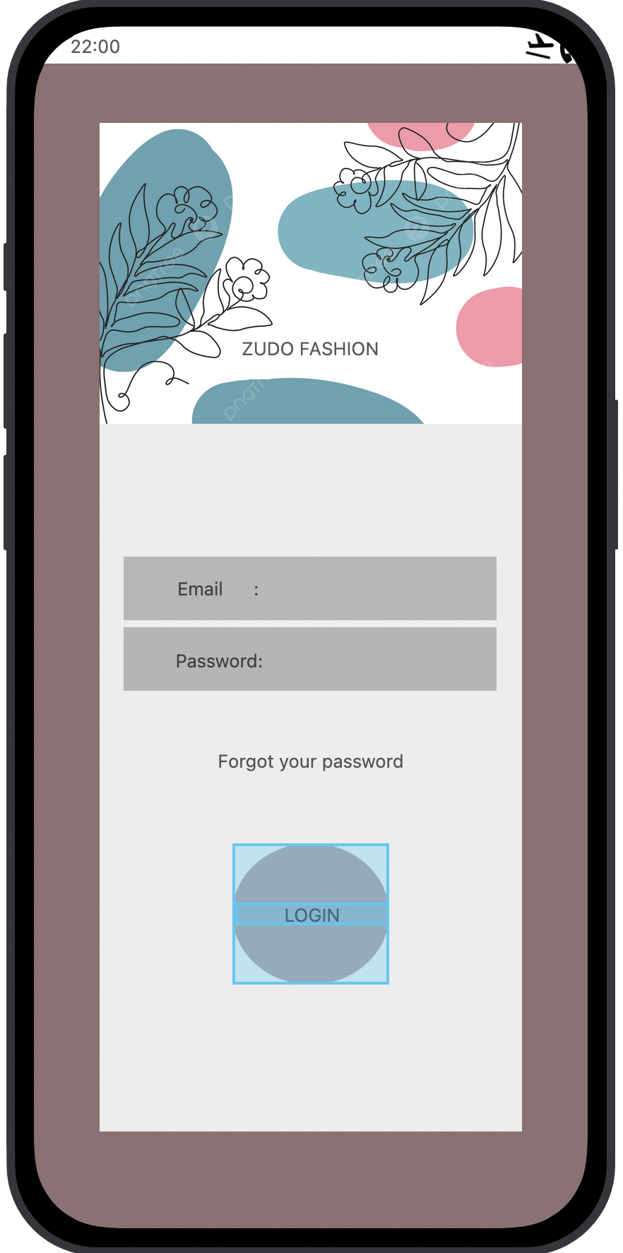
Login In page for the online shopping app

Familiar Icons:

1:Email / Phone field

2:Password field

3:Login button

4: Password visibility icon

5: Forgot Password link

Unfamiliar Icons:

1:Fingerprint icon for quick login

2: Swipe right anywhere to login

3: Animated glow when button tapped

Screen 2:

Home Page:

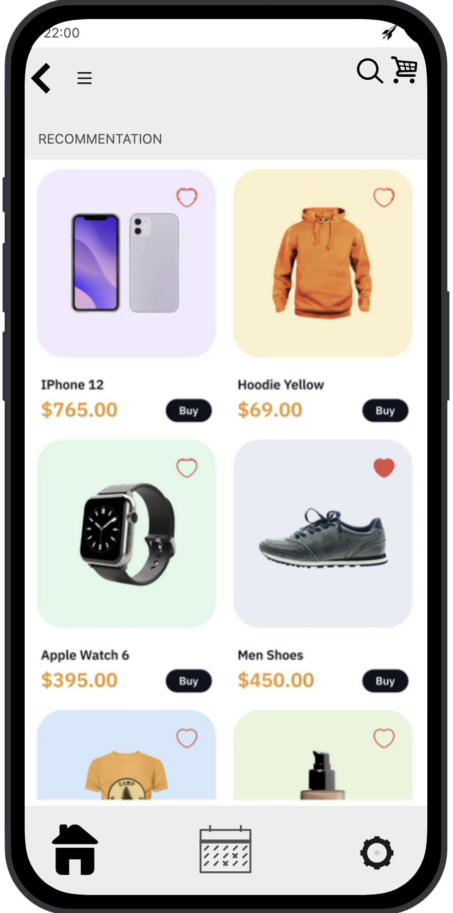

Familiar Icons:

1:Menu (top left)

2:Search icon

3: Cart icon

4:Category icons (Men, Women, Shoes, Electronics)

5: Product cards with price & rating

Unfamiliar Icons:

1: Swipe categories horizontally

2: Long-press product → quick preview popup

3: Floating “Quick Buy” button

4: Double-tap product → add to wishlist

Screen 3: PRODUCT PAGE

Familier Icons:

1:Back arrow

2: Product image carousel

3: Price & description

4: Ratings & reviews

5: Wishlist icon

6: Add to Cart button

Unfamiliar Icons:
1: Swipe up → add to cart

2:360° drag product view

3:Double tap image → zoom

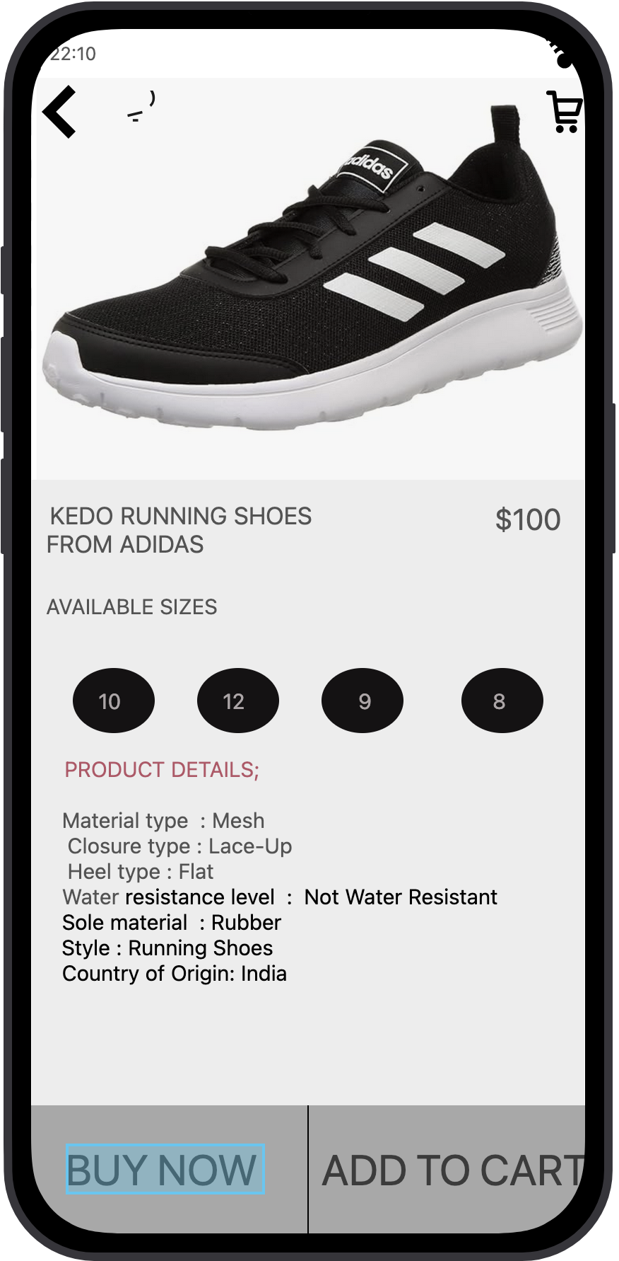
4:Shake phone → add to wishlist

Screen 4:

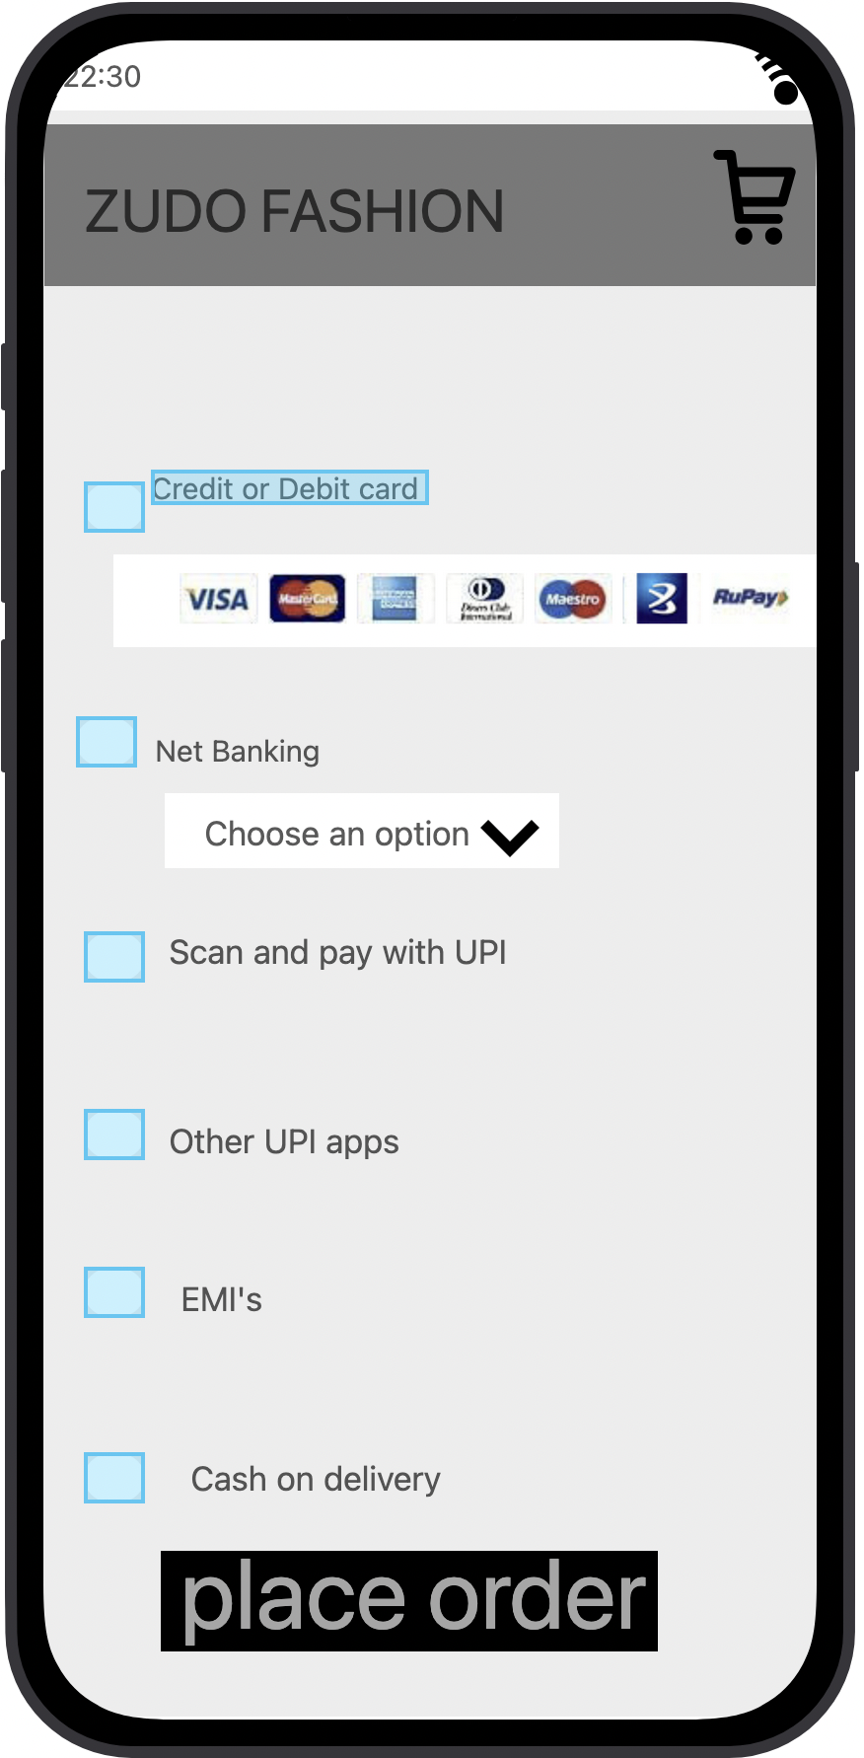
PAYMENT PAGE

Familier Icons:

1: Back arrow

2: Delivery address section

3: Payment methods (UPI / Card / COD)

4: Order summary (items & total)

5: Place Order button

Unfamiliar icons:

1: Slide to confirm payment
2: Tap & hold payment option → show details
3: Animated progress indicator
4: Voice confirmation option

Screen 5:
PAYMENT
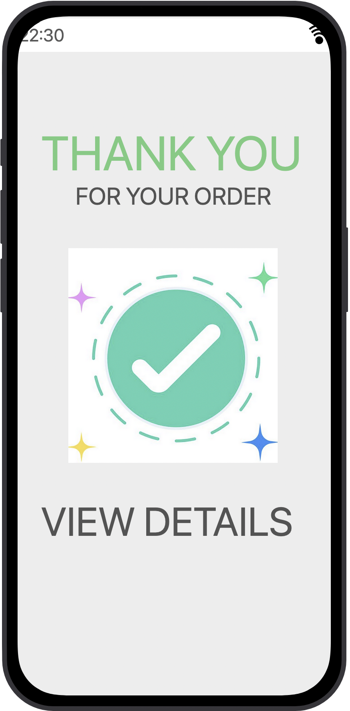
SUCCESS
PAGE

Familiear Icons:
1: Order Successful message
2:Delivery estimate date
3:Order ID / summary
4:Track Order button
5:Continue Shopping button

